No information in accessible formats or communication support when dealing with the NHS or social care organisations.
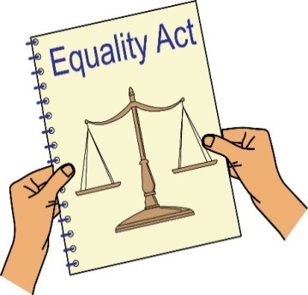
The NHS, which means GP practices, hospitals, Clinical Commissioning Groups as well as social care organisations have a duty to give information in accessible formats and communication support under the Equality Act.
Clinical Commissioning Group: this is a group that is part of the local authority that looks at what the health and social care needs are in their area. They then buy services to meet those needs.
Duty: this is something that someone or an organisation must do by law.

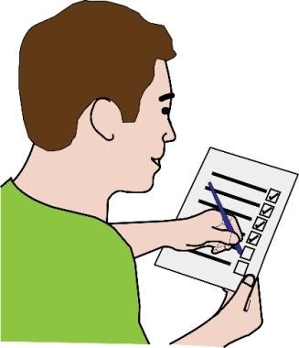
As well as this the NHS Accessible Information Standard says that they must find out about your communication needs, keep a record of this and give you accessible information or communication support. You can find more information about the NHS complaints procedure here: https://www.nhs.uk/chq/pages/1084.aspx?categoryid=68

To: Name of the GP practice, hospital trust or other NHS organisation
Their address
Their email address

From: Your name
Your address
Your phone number
Your email address

Date:

Dear (write the organisations name here)
Re: Complaint about Disability Discrimination

This is a letter of complaint, I would like it to be registered and investigated under your complaints procedure.
I am writing this letter to complain about the discrimination I experienced as a Disabled person and how you did not meet the NHS Accessible Information Standard.

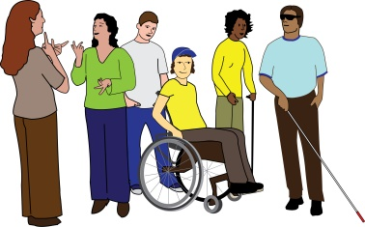
I am a Disabled person under the Equality Act 2010
I am a Disabled person within the meaning of section 6 of the Equality Act 2010.
I am a person with learning difficulties. As a person with learning difficulties I need support to understand complicated information. I need all written information to be in Easy Read.
Written information in Easy Read is where easy to understand words and sentences are used and supported by pictures, symbols and / or photographs to make this easier to understand.

What I am complaining about
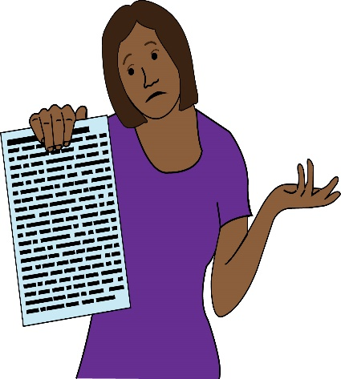
On the XXX (write the date of the incident here),
Write what happened, for example
I went to an appointment with Doctor XXX (write the name of the doctor here). The Doctor said that I should have surgery, this means a type of treatment for in injury or an illness. I was then given different leaflets explaining what this surgery is about, the risks and what I will have to do after the surgery has been done. I asked if I could have this information in Easy Read.

I was told that I could not get information in Easy Read. I needed this information to understand what would happen to me, what the risks are and what I need to do afterwards.
Describe how you felt, for example
I felt upset and angry. I was not given support to understand what will be done to my body and what the risks are. It made me very worried. I wasn’t given the same opportunity to make informed choices like everybody else.

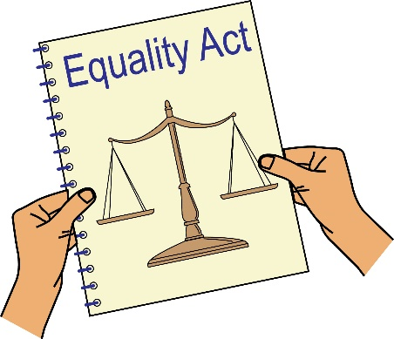
What the law says in my case
You are a service provider under Section 29 of the Equality Act 2010. Section 15 of the Equality Act says you must not discriminate against Disabled people because of something that comes as a result of their disability when running your public service.
Section 20 of the Equality Act 2010 says you must take reasonable steps to make sure Disabled people like me can access your services like everybody else.

Those steps should be:
- Changing policies or the way you run your service
- Removing physical barriers
- Giving help and support (auxiliary aid or service),
Information in accessible formats is an auxiliary service.
The NHS Accessible Information Standard says you should find out if I need information in a different format, keep a record of this and take steps to give me information in the format that I need.
The Mental Capacity Act says I should be supported to make decisions. This means you thinking about whether information could be given to me in a different way. Chapter 3 of the Mental Capacity Act Code of Practice explains how this should be done.
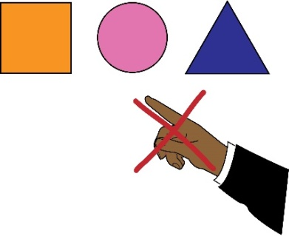
By not giving me information in the format I need you discriminated against me. You did not meet the NHS Accessible Information Standard and you did not take steps to make sure I could make informed decisions about what happens with my body.

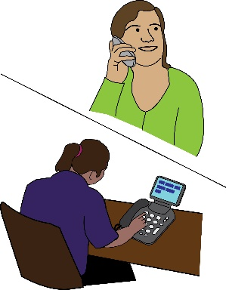
Getting information
Please send me the following information about the incident that I am complaining about:
- Any letters or emails about the incident, such as reports from staff
- The information that is on my file about my access needs
- Information about any policies you have about giving information in accessible formats.
What I would like to bring about through this complaint
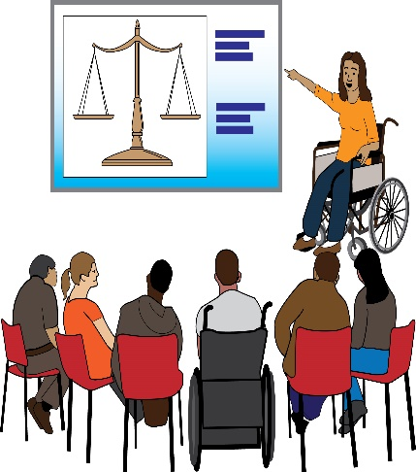
- You writing to me to say sorry for what you have done
- You to send information I need in easy-read
- A change in your policies and procedures making sure Disabled people who need information in accessible formats get it quickly
- An agreement from you to train your staff in Disability Equality and their duties under the Equality Act and the NHS Accessible Information Standard
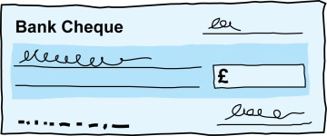
- Compensation for the discrimination and hurting of my feelings that I experienced.
Duties: this is something that someone or an organisation must do by law.
Compensation: this is something given to someone because of loss or suffering. It is usually money.

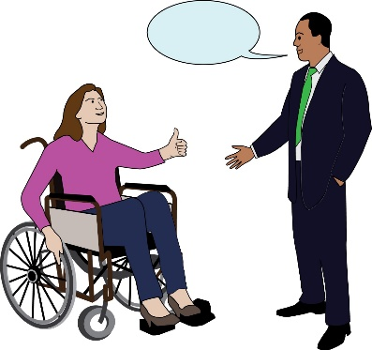
Next Steps
I very much hope we can sort out this problem. I look forward to hearing from you within the next 21 days.
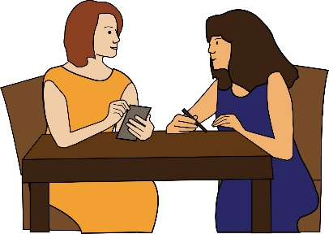
I am happy to talk with you about how we can deal with this issue. However, if I do not hear from you, or if you believe that you have not broken the law (Equality Act 2010), then I will get legal advice and think about what other options I have to make sure that you meet your duties by law.

Yours sincerely
(Write your name here)

