Local authority social services do not give me information in a format I need
The Equality Act 2010 says that local authorities must give information in accessible formats and communication support. This is part of its duty to make reasonable adjustments for Disabled people.
Duty: this is something that someone or an organisation must do by law.

As well as the Equality Act, the Care Act and the Care and Support Statutory Guidance , make it clear that local authorities should take steps to make sure a person can take part in their assessment and care planning. The Guidance says that local authorities must give information in accessible formats.
Statutory Guidance: this is a document that has rules about the Care Act that must be followed by local authorities.

Numbers below are paragraphs of the guidance which talk about accessible information

This could be:
- When the local authority gives a person information about assessments (6.22)

- When the local authority gives general information and advice (3.27). Here the Guidance talks about important information being in Easy Read.
- When the local authority gives a person information to support them taking part in their assessment (6.37). This could also be a list of questions that will be asked during the assessment being given to a person before the assessment (6.38)

- When the local authority gives a person a copy of their assessment document (6.98)

- When the local authority tells a person which needs they will meet or explains why they won’t meet a person’s needs (10.29)

- When the local authority gives information to a person about possible choices for care and support (10.33)
- When the local authority gives a person a copy of their care plan (10.89)

- When the local authority explains how the amount for a person’s personal budget has been decided (11.24)

- When the local authority says that they will not give a person direct payments and gives reasons why (12.22)

Use this template letter if local authority social services did not give you information in a format that is accessible to you.
Text in blue is an example, you need to change it so that it talks about the problem you faced.
To: Name of the local authority
Address of the local authority
Email address of the local authority

From: Your name
Your address
Your phone number
Your email address

Date:
Dear (write the name of the local authority here)
Re: Complaint about Disability Discrimination and not meeting duties in the Care and Support Guidance
This is a letter of complaint, I would like it to be registered and investigated under your complaints procedure.

I am writing this letter to complain because you are not sending me my social care documents in a format I need. I think this is against the law. This letter explains what went wrong and what you need to do to put things right.
I am a Disable person under the Equality Act 2010
I am a Disabled person within the meaning of Section 6 of the Equality Act 2010.
I’m a person with learning difficulties, I need support to read and understand complicated information. I need all written information to be in Easy Read.
Written information in Easy Read is where easy to understand words and sentences are used and supported by pictures, symbols and / or photographs to make this easier to understand.

What am I complaining about
Describe what happened and when
On XXX (write the date of the incident here) my social worker XXX (write the name of the social worker here) visited me to carry out an assessment of my care and support needs. At the meeting we talked about the difficulties I have reading and understanding information in standard print, this means information that has not been made accessible.
On XXX (write the date you got the letter here) I got a letter in standard print, which has information about my assessment and my care and support plan.
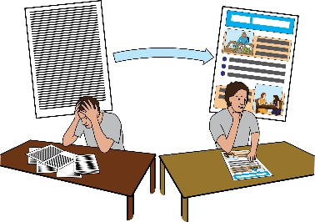
It was not in a format which is accessible to me. I could not read it. I was then offered a meeting where my social worker said they would go through this document with me. However, I think this is still not enough.
It would mean that I would still not be able to think about this information, make comments and make changes where I felt information was wrong. After the meeting I would forget what was said in that meeting and there would not be a document that I could read on my own which tells me what support I will be getting.
I was upset and angry. My independence, choice and control were not supported. I felt like I was a second class citizen.

What the law says in my case
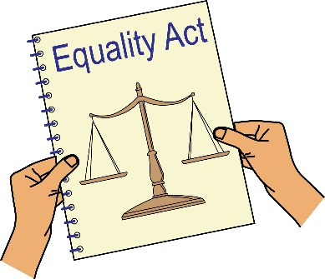
You are a service provider under Section 29 of the Equality Act 2010. Section 15 of the Equality Act says you must not discriminate against Disabled people because of something that comes as a result of their disability.
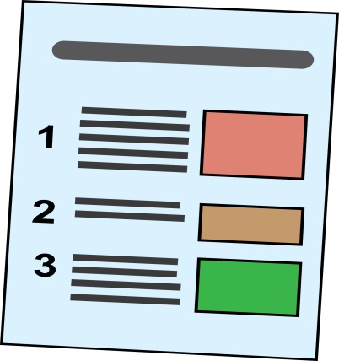
I did not get information in a format that I could read and understand. I could not take part in the process or challenge the decision. I cannot see any good reason for not giving me information in an accessible format.
Section 20 of the Equality Act 2010 says you must take reasonable steps to make sure Disabled people like me can access your services like everybody else.

Those steps should be:
- Changing policies or the way you run your service
- Removing physical barriers
- Giving help and support (auxiliary aid or service).
Information in accessible formats is an auxiliary service. I believe it was a reasonable step for you to take.
As well as this, the Care Act and the Care and support Statutory Guidance say that you must take steps to make sure a person can take part in their assessment and care planning. I cannot do this unless I am given information in a format that is accessible to me. The Guidance says you must give me an accessible format a copy of:
- My assessment (in paragraph 6.98)
- My eligibility decision, this means the decision about whether I will get support or not and what support I will get (paragraph 10.29)
- My Care Plan (paragraph 10.89)
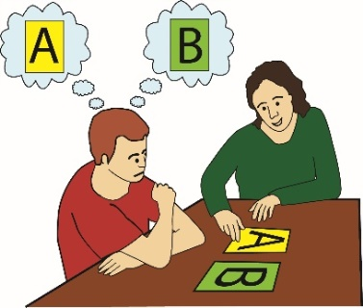
The Mental Capacity Act says I should be supported to make decisions. This also means you thinking about whether information could be given to me in a different way. Chapter 3 of the Mental Capacity Act Code of Practice explains how this should be done.
By not giving me information in the format that I need you discriminated against me.

Getting Information
Please give me the following information about the incident that I am complaining about:
- Any information on my file about my access needs
- Information about any policies or procedures you have on giving accessible information during care and support assessments and planning.

What I Would Like to Achieve by this Complaint
- you writing to me to sy sorry for what you have done
- My assessment and care plan sent to me in a format I need by XXX (write the date when you would like the document with you here).
- A change in your policies and procedures about giving information in accessible formats
- An agreement from you to train your staff, explaining their duties to give information in accessible formats.
- Compensation for the discrimination and hurting of my feelings that I experienced.
Duties: this is something that someone or an organisation must do by law.
Compensation: this is something given to someone because of loss or suffering. It is usually money.

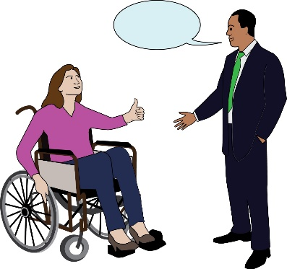
Next Steps
I very much hope we can sort out this problem. I look forward to hearing from you within the next 21 days.
I am happy to talk with you about different ways that we can deal with this issue. However, if I do not hear from you, or if you believe that you have not broken the law (Equality Act 2010), then I will get legal advice and think about what other options I have to deal with the discrimination I experienced.

Yours sincerely
(Write your name here)

All references are references to paragraphs of the Department of Health’s Care and Support Guidance

