Information was not given in an accessible format – when trying to use a public service, this means services run by public organisations such as local authorities, the police or government departments.
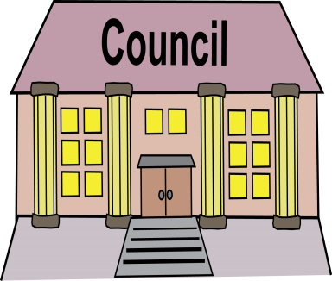
Use this letter if information in an accessible format was not given by a public organisation, such as a government department (like the Department for Work and Pensions), a local authority (your local council), a court, or the NHS.
The law says that public organisations must by law give Disabled people information in accessible formats as part of their services. For example this must happen when:
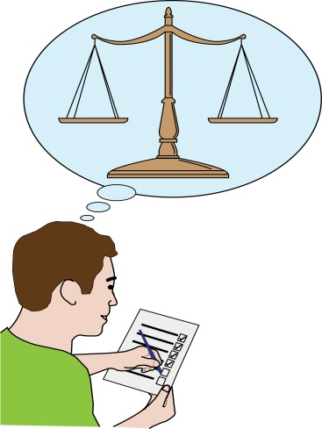
- Making decisions about your benefits
- Sending you fines, this is when someone must pay money because of something they have done wrong.
- Deciding about your case
- Looking into your complaint
- Or talking with you about their plans

If a public organisation did not give information in a format that you need it is likely that you have been discriminated against.
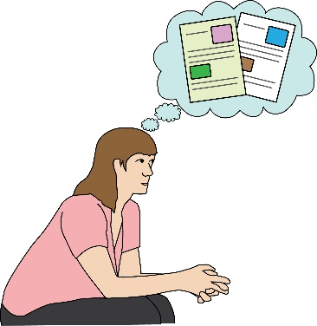
When you write this letter, think about what you want to get out of this, carefully. If the way in which a decision was made discriminated against you, you may want to ask the public organisation to rethink their decision. You may want them to do an assessment again; making sure information is given in an accessible format.
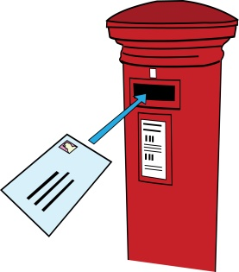
To: Name of the public organisation
Address of the public organisation
Email address of the public organisation

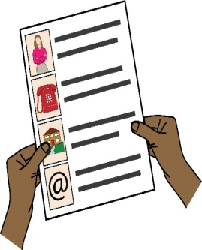
From: Your name
Your address
Your phone number
Your email address

Date:
Dear (write the public organisations name here)

Re: Complaint about disability discrimination – the Equality Act 2010
This is an official complaint, I would like it to be registered and investigated under your complaints procedure.
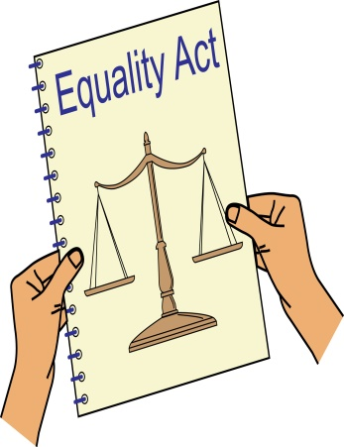
I am writing this letter of complaint because you did not give me information in the format I need. I would like you to make sure you meet the needs of Disabled people, when giving the service you give. I believe you have broken the law (Equality Act 2010). This letter explains what went wrong and what I want you to do to make things right.
I am a Disabled person under the Equality Act 2010
I am a Disabled person within the meaning of section 6 of the Equality Act 2010.
I am a person with learning difficulties. As a person with learning difficulties I need support to understand information. Extra efforts should be made to explain things to me in easy to understand words and written information should be in Easy Read.

Written information should be in Easy Read, this is where easy to understand words and sentences are used and are supported by pictures, symbols and / or photographs to make this easier to understand. You can find more information about Easy Read here: http://www.easyreadonline.co.uk/media/10612/comm%20basic%20guidelines%20for%20people%20who%20commission%20easy%20read%20info.pdf
The issue I am complaining about
On the XXX (write what date the incident happened here), I got a letter from you, telling me about what came out of my assessment for XXX benefit (write what benefit you were being assessed for here).
This letter was in standard size writing, even though I told you many times over the phone and in benefits forms that I need information in Easy Read.
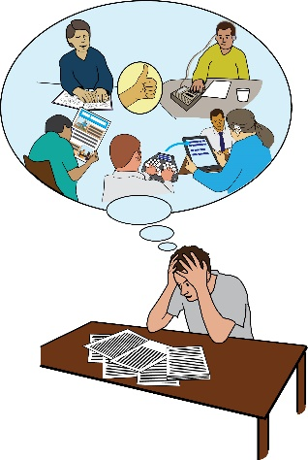
I need written information to be in easy to understand words with pictures, otherwise I cannot understand all of the information. You did not give this to me and because of this I could not understand what the letter said. I feel angry because I feel I am being treated as if I’m a second class citizen.
How you broke the law (Equality Act 2010)
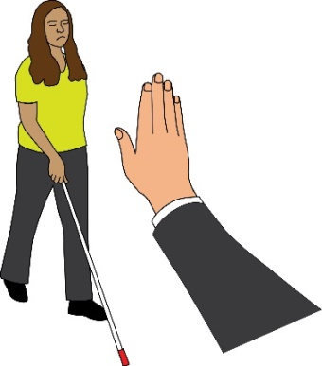
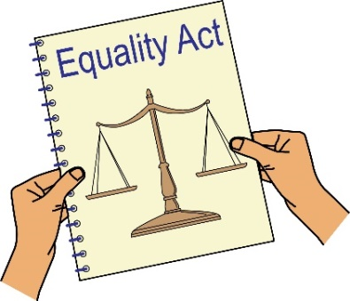
You are a public organisation running public functions under Section 29 of the Equality Act 2010. Section 15 of the Equality Act says you must not discriminate against Disabled people because of something that comes as a result of their disability when running your public service.
Section 20 of the Equality Act 2010 says you must take reasonable steps to make sure Disabled people like me can access your services like everybody else. Those steps should be:
- Changing policies or the way you run your service
- Removing physical barriers
- Giving extra help and support (auxiliary aid or service).
Information in accessible formats is an auxiliary service.
Section 20(6) of the Equality Act 2010 says that when a Disabled person needs information in an accessible format in order to access a service like everybody else, the reasonable steps to take include making sure that information is given in an accessible format.
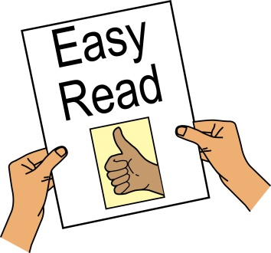
I told you that in order for me to understand your letters and do what you want me to do I need information in Easy Read. This has not been given to me.
By not sending information in the format that I need, you have not made a reasonable adjustment for me and therefore have discriminated against me.

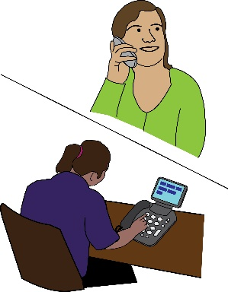
Getting information
Please send me the following information about the issue that I am complaining about:
- Audio recordings of the phone calls I made from ______ to __________.
- Any letters or emails about the incident;
- Information about any policies you have about giving information in accessible formats.

What I would like to bring about through this complaint
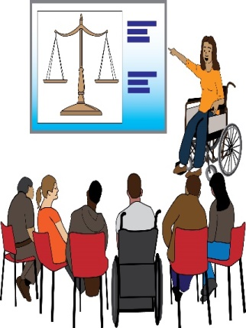
- You saying sorry for what you have done in writing.
- You change your policies and how you do things making sure Disabled people who need information in accessible formats get it quickly. Or a promise from you to write a policy on how you give information in accessible formats, making sure Disabled people are getting information in a format they need.
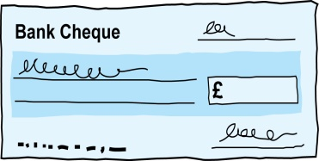
- A promise from you to train your staff in Disability Equality and their duties under the Equality Act.
- Compensation for the discrimination and hurting of my feelings that I experienced.
Duties: this is something that someone or an organisation must do by law.
Compensation: this is something given to someone because of loss or suffering. It is usually money.

Next steps
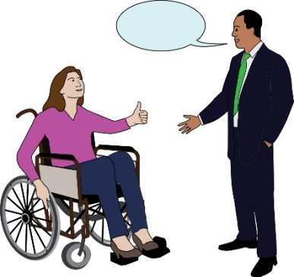
I very much hope we can sort out this problem. I look forward to hearing from you within the next 21 days. If you believe you have not broken the law (Equality Act 2010), please give your reasons.
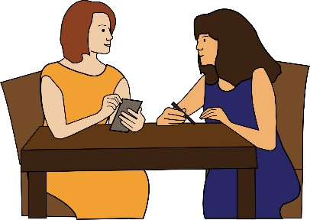
I am happy to talk with you about how we can deal with this issue. However, if I do not hear from you, or if you believe that you have not broken the law (Equality Act 2010), then I will think about taking legal action against you.

Yours sincerely
(Write your name here)

