Information was not given in Easy Read or another accessible format – when trying to use a service
Use this letter when you cannot get information in a format you need while trying to use a service. This could be for example, signing a contract with a utility company, a bank, buying tickets or other items, going to a restaurant, theatre, cinema, gym and other services.
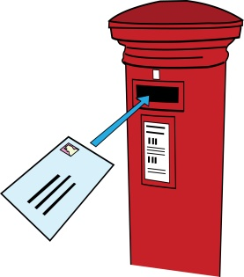
Do not forget to delete all the text explaining what you should do.

To: Name of the company which runs a service
Address of the company
Email address of the company

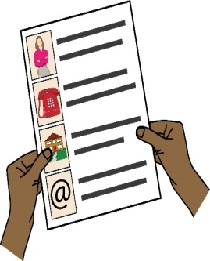
From: Your name
Your address
Your phone number
Your email address

Date:
Dear (write the company’s name here)

Re: Complaint about disability discrimination – the Equality Act 2010
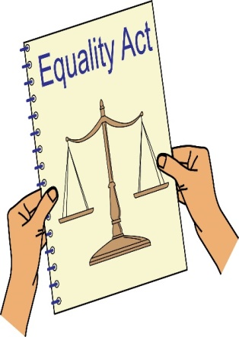
I am writing this letter of complaint because it was very hard for me to use your services. I would like you to make your service more accessible to me and other Disabled people who need information in accessible formats. I think you are breaking the law (The Equality Act 2010). This letter explains what went wrong and what I want you to do to make things right.

I am a Disabled person under the Equality Act 2010
I am a Disabled person within the meaning of Section 6 of the Equality Act 2010.

I am a person with learning difficulties. As a person with learning difficulties I need support to understand information. Extra efforts should be made to explain things to me in easy to understand words and printed information should be in Easy Read.

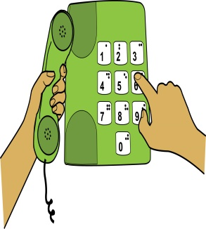
What I am complaning about
I wanted to start using your services. I (or my support worker) spoke to your customer service team on the phone and explained that I have learning difficulties and need a copy of my contract with you in Easy Read.
I was told this was not possible. As said above, I need written information to be in easy to understand words with pictures; otherwise I cannot understand all of the information. You did not give this to me and because of this I could not understand the contract I signed with you.
As said above, I need written information to be in easy to understand words with pictures; otherwise I cannot understand all of the information. You did not give this to me and because of this I could not understand the contract I signed with you. I feel angry as if I’m a second class citizen. I am still not sure if I have got the deal I wanted.

The accessible format or communication support I need
Written information in Easy Read is when easy to understand words and sentences are used and they are supported by pictures, symbols and / or photographs to help with understanding the text. You can find more information about Easy Read here: http://www.easy-readonline.co.uk/media/10612/comm%20basic%20guidelines%20for%20people%20who%20commission%20easy%20read%20info.pdf

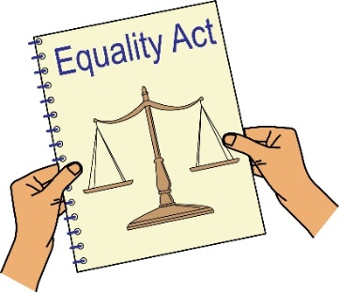
How you broke the law (Equality Act 2010)
You are a service provider under Section 29 of the Equality Act 2010. Section 15 of the Equality Act says you must not discriminate against Disabled people because of something that comes as a result of their disability.
Section 20 of the Equality Act 2010 says you must take reasonable steps to make sure Disabled people like me can access your services like everybody else.

Those steps should be:
- Changing policies or the way you run your service
- Removing physical barriers
- Giving extra support or help (auxiliary aid or service).
Information in accessible formats is an auxiliary service.

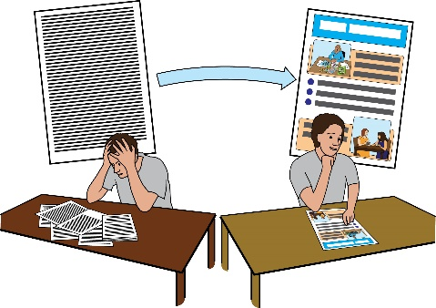
Section 20(6) of the Equality Act 2010 says that when a Disabled person needs information in an accessible format in order to access a service like everybody else, the reasonable steps to take include making sure that information is given in an accessible format.
I made it clear to you that in order to have the same choices as everybody else; I need information in Easy Read.

This has not been given to me and as a result I could not access your service. Therefore you have discriminated against me by not making reasonable adjustments so that I can access your services.

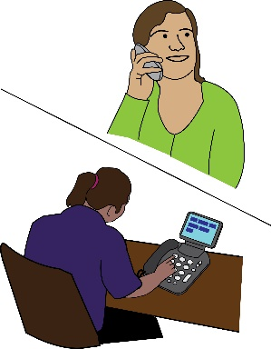
Getting information
Please send me the following information about the situation that I am complaining about:
- Audio recordings of the phone calls I made from ______ to __________.
- Any letters or emails about the incident;
- Information about any policies you have about giving information in accessible formats.

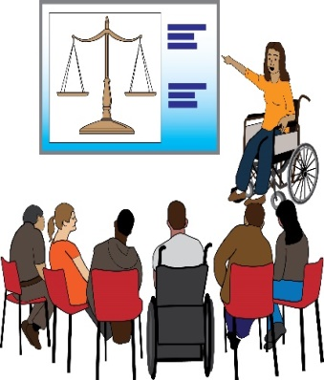
What I would like to bring about through this complaint
- You agreeing that what you have done is wrong and saying sorry to me in writing.
- A change in the way you run your service making sure Disabled people who need information in accessible formats get it without quickly.
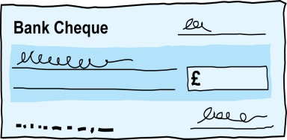
- An agreement from you to train your staff in Disability Equality and their duties under the Equality Act.
- Compensation for the discrimination and hurting of my feelings that I experienced.
Duties: this is something that someone or an organisation must do by law.
Compensation: this is something given to someone because of loss or suffering. It is usually money.

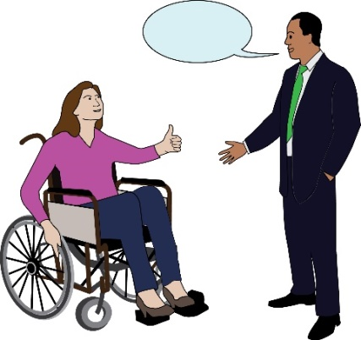
Next Actions
I very much hope we can sort this out. I look forward to hearing from you within the next 21 days. If you believe you have not broken the law (Equality Act 2010), please give your reasons.

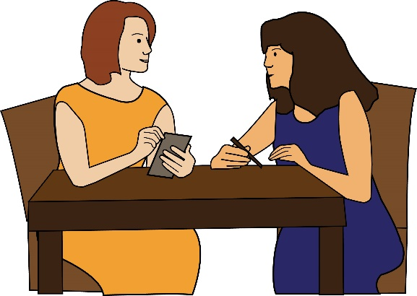
I am happy to talk with you about how we can deal with this issue. However, if I do not hear from you, or if you believe that you have not broken the law (Equality Act 2010), then I will think about taking legal action against you.

Yours sincerely

(Your name)

