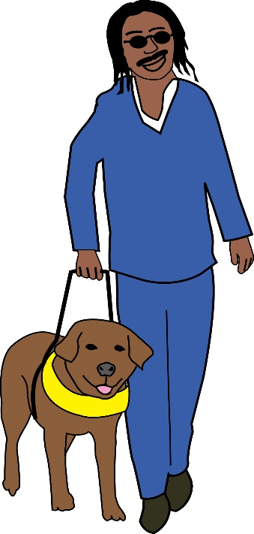
Complaint letter
Refusal to allow travel in a taxi because of guide dog

This letter is just n example. You need to change it so it is about the problem you faced. You need to change at least the text highlighted in yellow.
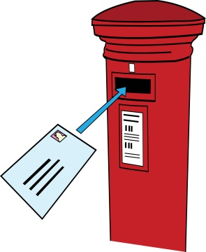

To: [Your local authority or Transport for London or the name of a minicab company]
Their Address
Also by email
From: Your name
Your Address:
Your Phone:
Your Email

[Date]

Dear [Your local authority or Transport for London or the name of a minicab company]

Re: Complaint about disability discrimination – the Equality Act 2010

I am writing this letter of complaint because of the problems I had when travelling by taxi from [place X] on [insert date]. I would like you to take steps to ensure taxis are more accessible to me and other Disabled people. I think I have been discriminated against. This letter explains what went wrong and what I want I want you to do to make things right.

I am a Disabled person under the Equality Act 2010

I am a Disabled person within the meaning of Section 6 of the Equality Act 2010. [Describe your condition and its impact on your ability to travel. For example: “I am blind and have a guide dog.”]
The issue I am complaining about
[Describe what happened, with date and time and what went wrong.
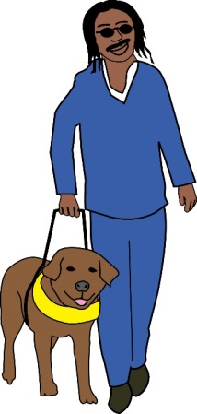
For example: “On [X date] I was trying to take a taxi at X Station. The station staff guided me to the taxi rank, where I approached a taxi with the vehicle registration number [X]” or “I used your app to call a minicab on the X date at X time to go from A to B. [The driver refused to let me in because I had a dog. I explained that it is a guide dog, but he did not want to listen.”]

[Describe the impact this had on you

For example: “As a result I had to approach other taxis, which was not easy for me to do, as I could not see where they were. I stood at a taxi rank waiting for a driver who would agree to take me. I felt humiliated and more like a second class citizen. I am now less confident approaching taxis and feel anxious about travelling with my guide dog.”

[Describe whether this situation happens regularly]

How you breached the Equality Act 2010

A taxi driver is a service provider under Section 29 of the Equality Act 2010.

Section 15 of the Equality Act says service providers must not discriminate against Disabled people because of something connected to their disability.

Section 20 of the Equality Act 2010 requires you to make sure Disabled people can access service like everybody else.
Those steps should be:
- Changing policies or the way you run your service
- Removing physical barriers
- Giving extra support or help (auxiliary aid or service).

The driver knew I am a Disabled person and why I need my guide dog. My dog has a special harness and a coat which indicate clearly that it is an assistance dog. I believe I was discriminated against because of something connected to my disability: my guide dog.

The Equality Act says a driver could only do this if there was a very good reason. The driver did not give me a reason why I could not get in the taxi.

The duty to make reasonable adjustments requires you to make an exception to any rules about the carriage of animals in a car and to change the way you provide your service accepting passengers who use guide dogs.

Obtaining Information
Please provide me with the following information about the incident that I am complaining about:

- the licence agreement the driver has and any exemptions that have been made.

What I would like to bring about through this complaint
- You agreeing that what you have done is wrong and saying sorry to me in writing;
- a change in the way you provide service ensuring Disabled people with guide dogs can always access it;
- or if a complaint is to a local authority: an action taken against the driver;
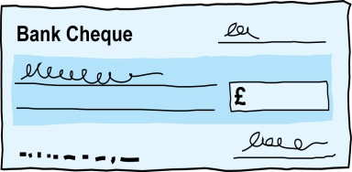
- Compensation for the discrimination and hurting of my feelings that I experienced.

Duties: this is something that someone or an organisation must do by law.
Compensation: this is something given to someone because of loss or suffering. It is usually money.

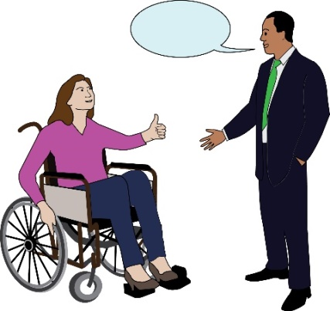
Next steps
I very much hope we can sort this out. I look forward to hearing from you within the next 21 days. If you believe you have not broken the law (Equality Act 2010), please give your reasons.

I am happy to talk with you about how we can deal with this issue. However, if I do not hear from you, or if you believe that you have not broken the law (Equality Act 2010), then I will think about taking legal action against you.

Yours sincerely
(Your name)

