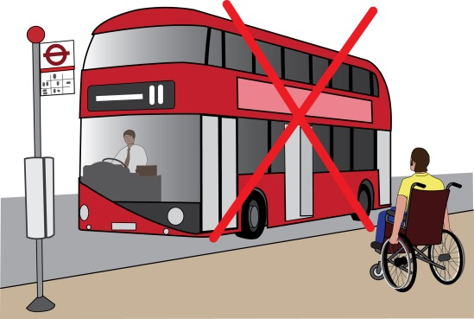
Complaint letter
Unable to get on a bus because the wheelchair space was taken by someone else

This letter is just an example. You need to change it so it is about the problem you faced. You need to change at least the text highlighted in yellow.

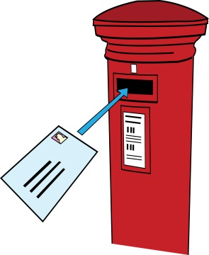
To: [Bus company’s name or Transport for London if a problem occurred on a London bus]

Bus company’s address
Also by email
From: your name
Your address:
Your Phone:
Your email

Date

Dear [Bus Company’s name / Transport for London]

Re: Complaint about disability discrimination – the Equality Act 2010

I am writing this letter of complaint because of difficulties I had getting on the [insert bus name/number/route] bus at the [X stop] on [insert date]. I would like you to make your service more accessible for myself and other Disabled people who travel by bus. I believe you did not comply with the law. This letter explains what went wrong and what I would like you to do to make things right.

I am a Disabled person under the Equality Act 2010

I am a Disabled person under Section 6 of the Equality Act 2010. I have [X condition] which means [describe the impact of your condition on your ability to travel, for example: I’m a wheelchair user and I am unable to get on or off the bus without a ramp and I can only travel in a wheelchair space.]

What I am complaining about
[Give details of your journey/journeys. For example: “On [X date] at approximately [X time], I attempted to get on the [X bus number] bus at the [X stop.”]

[Describe what went wrong. For example: “I was unable to get on the bus, because there was a buggy in a wheelchair space. The driver did not do anything to help free this space.”]

[Describe the impact this had on you.
For example: “As a result not only I was late for my meeting, the difficulties with my journey affected my (physical) and mental health. I felt humiliated and angry and now I feel less confident using public transport.”]

[Describe whether this situation happens regularly.]

How you breached the Equality Act 2010

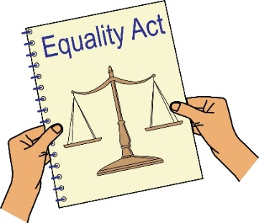
You are a service provider under Section 29 of the Equality Act 2010, which requires you to make reasonable adjustments to ensure Disabled people can access your service.

Section 20 of the Equality Act 2010 requires you to make sure Disabled people can access service like everybody else.
Those steps should be:
- Changing policies or the way you run your service
- Removing physical barriers
- Giving extra support or help (auxiliary aid or service).

In 2017 in the case of Paulley v FirstGroup PLC the Supreme Court decided that it would be reasonable for a driver not only to ask other passengers to free up a wheelchair space, but also to take further steps to persuade them, which could include rephrasing the request as a requirement or refusing to drive on for some time.
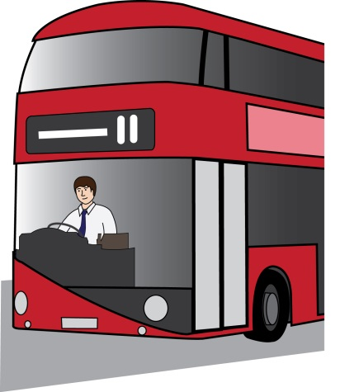

The driver in my case did not take those steps . This means I was subjected to discrimination contrary to the Equality Act. You are responsible for the driver’s actions because they are your employee.

Obtaining information

Please provide me with the following information about the incident that I am complaining about:

- CCTV footage; Describe how you look or attach a photo

- Any letters or emails relating to the incident, including any reports from the driver;

- Details of any policies you have in respect of the use of a wheelchair space on the bus.

What I would like to bring about through this complaint

- You agreeing that what you have done is wrong and saying sorry to me in writing;
- A commitment from you to train all of your drivers about Disability Equality, their duties under the Equality Act and the Paulley decision in particular;
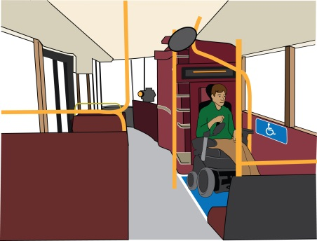
- A change to your policy on the use of wheelchair spaces, ensuring it complies with the Paulley judgement.
- Compensation for the discrimination and hurting of my feelings that I experienced.

Duties: this is something that someone or an organisation must do by law.
Compensation: this is something given to someone because of loss or suffering. It is usually money.

Next steps
I very much hope we can sort this out. I look forward to hearing from you within the next 21 days. If you believe you have not broken the law (Equality Act 2010), please give your reasons.

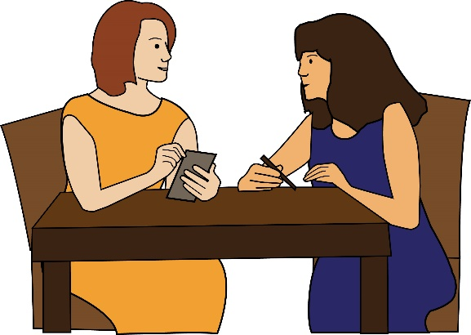
I am happy to talk with you about how we can deal with this issue. However, if I do not hear from you, or if you believe that you have not broken the law (Equality Act 2010), then I will think about taking legal action against you.

Yours sincerely
(Your name)

