Complaint letter
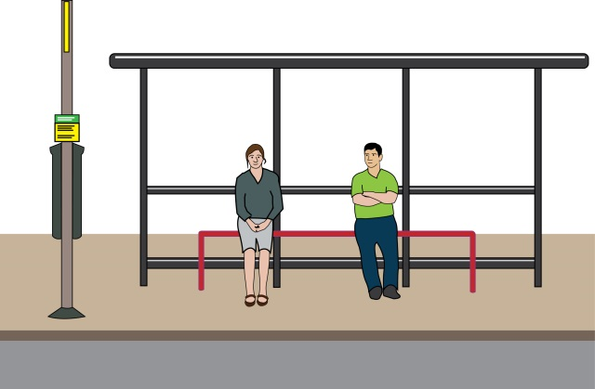
Unable to get on a bus because the bus did not stop for me or the bus pulled up too far or in a way which prevented me from getting on

This letter is just an example. You need to change it so it is about the problem you faced. You need to change at least the text highlighted in yellow.

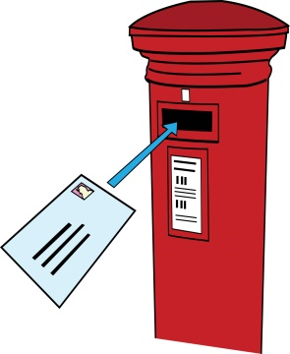
To: Bus company’s name (or Transport for London if a problem occurred on a London bus)
Bus company’s address
Bus company’s email address
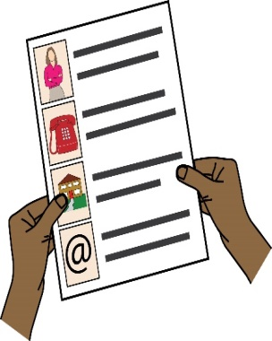
From: your name
Address: your address
Phone: your phone number
Email: your email address
Date
Re: Complaint about disability discrimination – the Equality Act 2010
I am writing this letter of complaint because of difficulties that I experienced getting on the [N] bus at the [X stop] on [insert date]. I would like you to make your service more accessible to myself and other Disabled people who travel by bus. I believe you did not comply with your duties under the Equality Act 2010. This letter explains what went wrong and what I would like as an outcome of my complaint.
I am a Disabled person under the Equality Act 2010
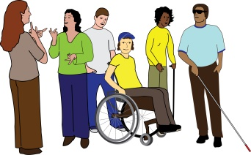
I am a Disabled person under Section 6 of the Equality Act 2010. [Describe your condition and its on your ability to travel. For example: “I’m a blind or visually impaired person. I do not see bus numbers and often rely on other people to guide me to the front door of the bus.”]
The issue I am complaining about
[Give details of your journey/journeys. For example: On [X date] at approximately [X time], I attempted to get on the [N] bus at [Stop X]]
[Describe what went wrong. For example: “The driver clearly saw me at a bus stop, but did not stop the bus” or “The driver stopped the bus far from the bus stop, and I did not see it and therefore could not get on.”]
[Describe the impact this had on you, For example: “This left me feeling humiliated, and I had to wait in the cold for half an hour. As a result not only I was late for my meeting, Now I am always really worried when I have to travel by bus.
How you breached the Equality Act 2010

You are a service provider under Section 29 of the Equality Act 2010. Section 15 of the Equality Act says you must not discriminate against Disabled people because of something arising as a consequence of their disability.

Section 20 of the Equality Act 2010 requires you to make sure Disabled people can access service like everybody else.
Those steps should be:
- Changing policies or the way you run your service
- Removing physical barriers
- Giving extra support or help (auxiliary aid or service).

The driver clearly saw that I am a Disabled person and that I wanted to get on the bus. I believe I was discriminated against because of something arising as a consequence of my disability:

There was no good reason for this, because the bus stop was free.
Obtaining information
Please provide me with the following information about the incident that I am complaining about:
- CCTV footage of me taken on [X date]; [Describe how you look or attach a photo]
- Details of any policies you have in respect of delivering services to Disabled people.
What I would like to bring about through this complaint
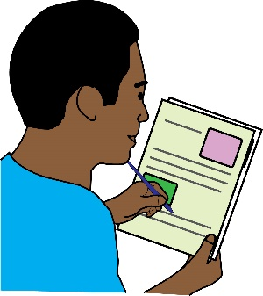
- You agreeing that what you have done is wrong and saying sorry to me in writing;
- You agreeing to train all of your drivers about Disability Equality, their duties under the Equality Act;
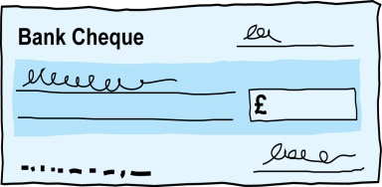
- Compensation for the discrimination and hurting of my feelings that I experienced.

Duties: this is something that someone or an organisation must do by law.
Compensation: this is something given to someone because of loss or suffering. It is usually money.

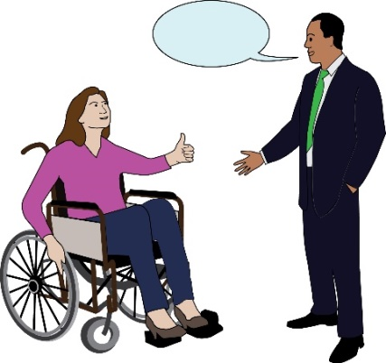
Next steps
I very much hope we can sort this out. I look forward to hearing from you within the next 21 days. If you believe you have not broken the law (Equality Act 2010), please give your reasons.

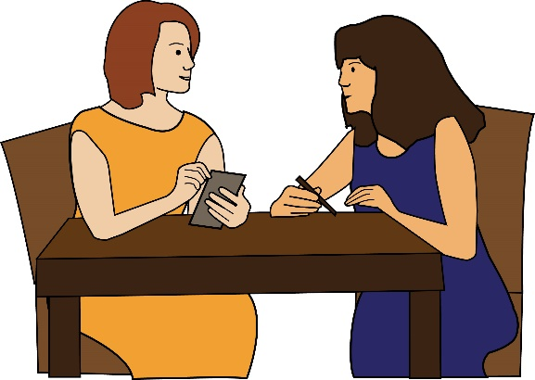
I am happy to talk with you about how we can deal with this issue. However, if I do not hear from you, or if you believe that you have not broken the law (Equality Act 2010), then I will think about taking legal action against you.

Yours sincerely
(Your name)

