Complaint letter
Audio visual announcements or a ramp did not work on a bus

This letter is just an example. You need to change it so it is about the problem you faced. You need to change at least the text highlighted in yellow.

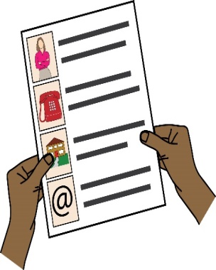
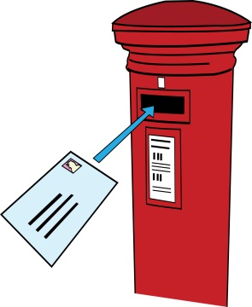
To: [Bus company’s name or Transport for London if a problem occurred on a London bus]
Bus company’s address
Bus company’s email address
From: your name
Address: your address
Phone: your phone number
Email: your email address
[Date]
Dear [Bus company’s name or Transport for London]
Re: Complaint about disability discrimination – the Equality Act 2010
N bus, from the X stop to the Y stop on insert date.
I would like you to make your service more accessible to myself and other Disabled people who travel by bus. I believe you did not comply with your duties under the Equality Act 2010. This letter explains what went wrong and what I think you should do to make things right.
I am a Disabled person under the Equality Act 2010
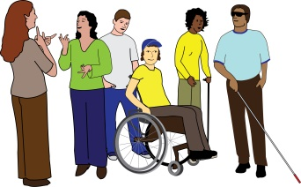
I am a Disabled person under Section 6 of the Equality Act 2010. [Describe your condition and its impact on your ability to travel. For example: “I’m a wheelchair user, and I am unable to get on or off the bus without a ramp and I can only travel in a wheelchair space.”]
What I am complaining about
[Give details of your journey or journeys. For example: “On [X date] at approximately [X time], I attempted to get on the [N] bus] at the [X stop]”]
[Describe what went wrong. For example: “The driver clearly saw me at a bus stop, but did not operate the ramp” or “I missed my stop, because audio- visual announcements were switched off and the driver did not tell me when my stop was”]
[Describe the impact this had on you For example: “This left me feeling humiliated. As a result not only I was late for my meeting, I am now very worried when I have to travel by bus.
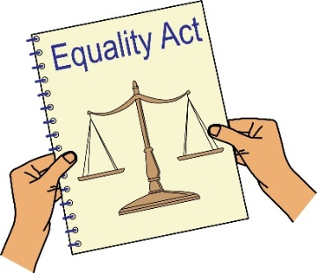
How you breached the Equality Act 2010

You are a service provider under Section 29 of the Equality Act 2010, which requires you to make reasonable adjustments to ensure Disabled people can access your service.

Section 20 of the Equality Act 2010 requires you to make sure Disabled people can access service like everybody else.
Those steps should be:
- Changing policies or the way you run your service
- Removing physical barriers
- Giving extra support or help (auxiliary aid or service).

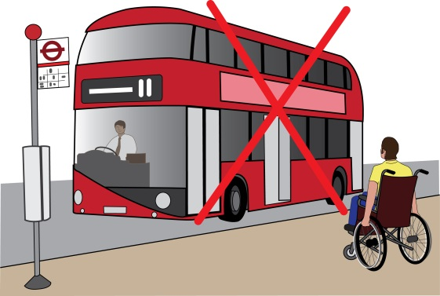
I refer you to the Statutory Code of Practice, issued by the Equality and Human Rights Commission under the Equality Act, which says at para 7.46:

That you should ensure that any aids you provide are in working order and have a backup plan for when they break. In my case the aid that was there to help me to travel like everybody else, was not operated or was not working and the driver did not do anything to help me. I believe this means you are in breach of your duty to make reasonable adjustments under the Equality Act 2010.
Obtaining information
Please provide me with the following information about the incident that I am complaining about
- CCTV footage; Describe how you look or attach a photo
- Any letters, emails or reports relating to the incident, including any report from the driver, any reports explaining why the aid I needed was not working and the log of any actions taken to fix it.
- Details of any policies you have in respect of the use of ramps or audio-visual announcements and procedures that must be followed when those aids are not working.
What I would like to bring about through this complaint
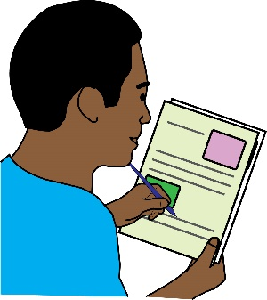
- You agreeing that what you have done is wrong and saying sorry to me in writing;
- An agreement from you to train all of your drivers about Disability Equality, their duties under the Equality Act.
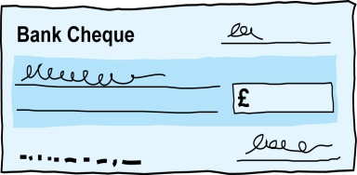
- Compensation for the discrimination and hurting of my feelings that I experienced.

Duties: this is something that someone or an organisation must do by law.
Compensation: this is something given to someone because of loss or suffering. It is usually money.

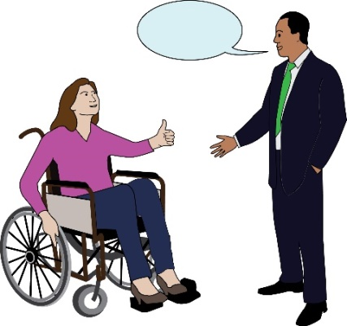
Next steps
I very much hope we can sort this out. I look forward to hearing from you within the next 21 days. If you believe you have not broken the law (Equality Act 2010), please give your reasons.

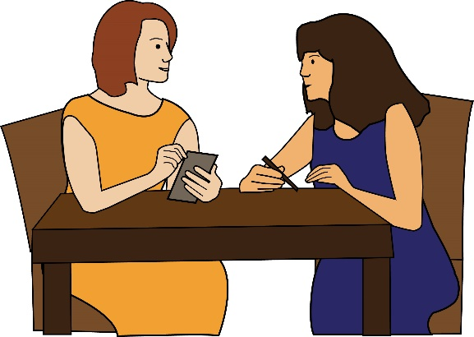
I am happy to talk with you about how we can deal with this issue. However, if I do not hear from you, or if you believe that you have not broken the law (Equality Act 2010), then I will think about taking legal action against you.

Yours sincerely
(Your name)

