Complaint letter: Failed to receive assistance on a train journey

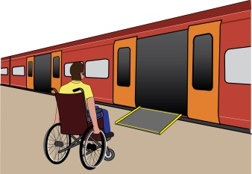
Complaint letter

This letter is just an example. You need to change it so it is about the problem you faced. You need to change at least the text highlighted in yellow.

To: Rail Company’s name

Address
Also by email
From: your name
Address:
Phone:
Email

Date:

Dear [Rail company’s name]

Re: Complaint about disability discrimination – the Equality Act 2010
I am writing this letter of complaint because of difficulties that I experienced when traveling from station A to station B on (insert date). I would like you to make your service more accessible to me and other disabled people, who need assistance to travel. I believe you did not comply with your duties under the Equality Act 2010. This letter explains what went wrong and what I want as an outcome of my complaint.

I am a Disabled person under the Equality Act 2010

I am a Disabled person under section 6 of the Equality Act 2010. I have X condition which means [describe the impact of your condition on your ability to travel, for example: I’m a wheelchair user, and I am unable to get on or off the train without a ramp].

What I am complaining about

Give details of your journey/journeys, for example: On the X date I was traveling from Station A to Station B.
Describe what exactly went wrong.
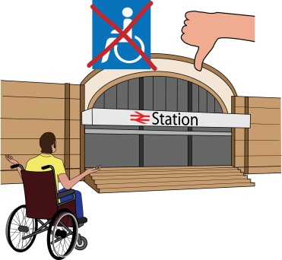
Example: I arrived at Station A at (time) and approached a member of your staff, who was at the platform. I asked them for assistance with boarding 9:30am train to station B. The staff member refused and I was told that I would only be able to get assistance to board the later train, which meant I had to spend 50 minutes waiting in the cold. When I asked a member of staff why it was not possible for him to bring a ramp and assist me with getting on the 9:30am train, I was told he was busy with something else.

Or
Example: On X date I travelled on the train from station A to Station B, which departed station A at 10:00am. I had assistance to board the train at station A, but when the train arrived at Station B there was no one there to help me get off the train. I had to ask other passengers to help me, which was a frightening experience for me.

Describe how it made you feel.
Example: As a result not only I was late for my meeting, the difficulties with my journey affected my physical and mental health. I felt humiliated and angry and now I feel less confident using public transport.

Describe whether this situation happens often, for example if you have to take a certain train for work or any other important regular commitments.

How you breached the Equality Act 2010

You are a service provider under Section 29 of the Equality Act 2010, which requires you to make reasonable adjustments to ensure disabled people can access your service. Section 20 of the Equality Act 2010 requires you to make sure Disabled people can access service like everybody else.
Those steps should be:
- Changing policies or the way you run your service
- Removing physical barriers
- Giving extra support or help (auxiliary aid or service).

Helping Disabled people like me to get on and off trains is an auxiliary aid.

I believe you discriminated against me by failing to help me get on the train.

Obtaining information

Please provide me with the following information about the incident that I am complaining about

- CCTV footage; [describe how you look or attach a photo]
- Any internal and external reports or emails relating to the incident;
- Details of any policies you have in respect of assisting disabled service users to access your trains.

What I would like to bring about through this complaint

- You agreeing that what you have done is wrong and saying sorry to me in writing;
- A change to your policy, guaranteeing good quality assistance to all Disabled passengers who are traveling on your trains;
- Changing the way you provide help at station X by guaranteeing help to all Disabled passengers, even those who did not book it in advance;
- Compensation for the discrimination and hurting of my feelings that I experienced.

Duties: this is something that someone or an organisation must do by law.
Compensation: this is something given to someone because of loss or suffering. It is usually money.

Next steps
I very much hope we can sort this out. I look forward to hearing from you within the next 21 days. If you believe you have not broken the law (Equality Act 2010), please give your reasons.

I am happy to talk with you about how we can deal with this issue. However, if I do not hear from you, or if you believe that you have not broken the law (Equality Act 2010), then I will think about taking legal action against you.

Yours sincerely
(Your name)

