Disability Justice Project
Discrimination guide

Physical barriers
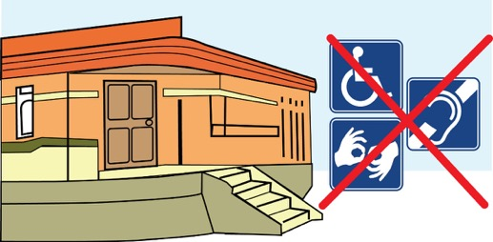
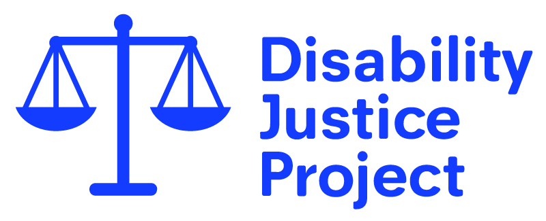

About this guide
We experience day-to-day discrimination. Many of us don’t always realise that what is happening is against the law. Others feel unable to do anything about it.
That is why we put this guide together.
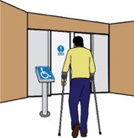
This guide covers what to do if you have had difficulties with physical access, getting into buildings, or not having access to accessible toilets. Please use our other guides for support when you:
- have difficulties using public transport or taxis
- have difficulties getting information in the format you need
- cannot get adaptations made to your home
Adaptations: here, this means changes made to a person’s home to make it accessible to them.
- have difficulties accessing public engagement and consultations
Public engagement: this is when a person or organisation bring people together to talk about or deal with an issue.
Consultations: this is where a person or organisation asks people what they think about something, it could be a new policy or a change in the way something is done.

These guides look at problems that Disabled people experience. They will help you to see whether you have experienced discrimination.
They will take you through the process of dealing with discrimination step by step. You will find template letters you can use. You will also find useful tips on getting evidence and places to find more information and advice.
Template: this is an example letter or document. It can usually be changed so that a person can put their own information into the document.
Evidence: this means proof that something has happened.

It has been illegal to discriminate against Disabled people for more than 20 years. However, we still face many barriers and sometimes find it impossible to access services.
This is mainly because it is left up to us to make sure that the law is used. By taking action to fight discrimination, you aren’t only making changes for yourself, you are making things better for other Disabled people.

What the law says
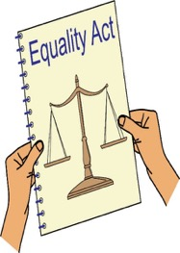
Public organisations that offer goods and services must take reasonable steps to get rid of physical barriers that Disabled people might experience when accessing their services. They must do this by law (Equality Act 2010).
Reasonable: this means that something is dealt with in a fair way.

Physical barriers can mean things such as:
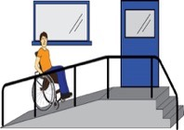
- Steps
- Stairways
- Kerbs, this means the edge of the pavement
- Exterior surfaces, this means outside spaces and how they are covered e.g. pavements
- Parking areas
- Building entrances and exits (this also means emergency escape routes)
- Doors in a building and on the outside
- Gates
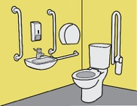
- Toilets and washing facilities
- Public facilities (such as telephones, counters or service desks)
- Lighting and ventilation, this means how fresh air gets into a room
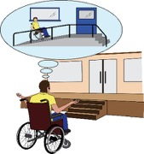
- Lifts and escalators
- Floor coverings
- Signs
- Furniture
- Temporary items, this means things that are there for a short amount of time, or items that can be moved (such as equipment and display racks)
To get rid of physical barriers, organisations that run services must:
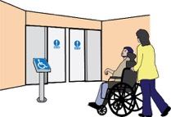
- Get rid of the physical item that is a barrier. For example: getting rid of furniture that is blocking the way.
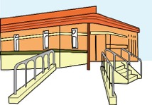
- Change the way the physical area is set up so that there are no barriers. For example: making doors wider, getting rid of walls, putting in an accessible toilet or a changing places toilet, or changing where the seats are in a theatre.
- Give a reasonable way of getting around the physical barrier. For example: building a ramp or putting in place a stair lift.

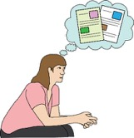
If it is not possible or reasonable to do any of the above, organisations must think about whether there is any auxiliary aid or service they can offer to get rid of the physical barrier. For example, a portable ramp or support for guiding a person.
Auxiliary aid: this means giving extra support or services.
Portable ramp: this means a ramp that can be put up and taken down when needed.

The organisation that runs a service or the public organisation should always make sure Disabled people can get the same service as everybody else.
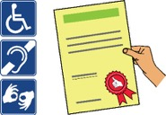
When it is impossible to get rid of a physical barrier or find a reasonable way of getting around it, but only then, an organisation can think about having another way of making a service accessible to Disabled people.
However, this other way of getting rid of the barrier should not make people feel stressed or be more difficult to use. For example, serving Disabled customers outside the shop instead of making sure they can get in would not be a good way of making a service accessible.
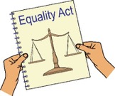
Any equipment or adjustments must be working and ready to use. If the lift is not working or the ramp is blocked, the organisation may be breaking the law (Equality Act).
Adjustment: this means making a change.

As well as this, when extra barriers are created, for example a locked accessible toilet or an accessible toilet being used as storage, they will in most cases be breaking the law (Equality Act).
Organisations that run services and public organisations must think about the physical barriers that may stop Disabled people from accessing their services. They cannot wait for a Disabled person to walk through the door before starting to do this.
Adjustments made should work for you. If a company has already made some changes which do not work for you, they must still think about what reasonable steps they can take to make a change that is good for you.

If physical barriers are found and an organisation that runs services cannot take reasonable steps to get rid of them in time, they should at least let Disabled customers know.
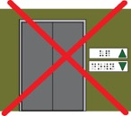
For example: if you booked an appointment with a dentist whose office is on the second floor, it would be reasonable for the dentist to get in touch with you to change your appointment if the lift has broken.
Adjustments that are made should push for your independence and respect your dignity; they should not make you feel uncomfortable. Offering to push a person who uses a wheelchair inside the building instead of having a portable ramp will not be an adjustment that pushes for independence or respects dignity.
Dignity: this means that a person and their opinions or wishes are important and listened to. This also means being treated with respect.

Sometimes organisations that run services can give reasons for not making changes by saying that they could not make changes because of the lease they have for the space they are renting.
Lease: this is the type of contract or written agreement used when renting somewhere.

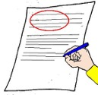
In that case, it is always good to check what steps they took when asking their landlord to make changes. If they did not ask the landlord in writing, then they cannot use their lease as a reason for not doing anything.
Landlord: this is the owner of a place that is being rented.

Even in a situation when a landlord does not agree to the physical change, the organisation running the service should think about whether there is anything they could do that does not need the landlord’s agreement.

If you could not:
- access the building;
- use toilet facilities, changing rooms or washing facilities;
- find your way because of bad signs;
- or had a sensory overload because the lighting was too bright,
you most likely have been discriminated against.
Sensory overload: this is when a person can feel too much with their senses, this could be touch, smell, sound or seeing strong or flashing lights.

What you can do if things go wrong
If you could not access a service like everybody else because of a physical barrier, you can make a complaint to stop this from happening again. Your complaint could lead to changes that will help many other Disabled people.
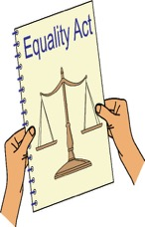
In many cases the company will have broken the law (Equality Act) and you will be able to take legal action against them and ask for compensation for the discrimination you have experienced.
Compensation: this is something given to someone because of loss or suffering. It is usually money.

Differences between a complaints and legal action

Complaint
Issues you can raise: You can raise any issues linked to specific incidents. You can also talk about any problems you keep on having over a long amount of time.
Incident: this is an event or when something happens.

Outcomes you can achieve, this means what can happen because of your complaint: You can get:
- An apology, this means them understanding what they have done and saying sorry
- An agreement to make the service better
- An explanation of why things went wrong

Risks: No financial risk, this means that you will not risk losing any money if you do this.
Process: the Company’s complaints procedure.
Complaints procedure: these are the steps taken by an organisation when someone makes a complaint.

Time: There is no time limit, but you should make a complaint as soon as possible.

Legal Action: this means using the law to take a case

Issues you can raise: Legal action must be about a specific incident when you think the company did not follow the law.

Outcomes you can achieve, this means what can happen because of your complaint: You can get:

- An order saying that you were discriminated against and that the organisation should not do this again
Order: this is a document from the court telling someone that they must do or not to do something.

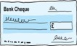
- Financial compensation, this means getting money to make up for any damage caused

- A court order that the company changes the way it works, this can also be called an injunction

Risks: there are financial risks, this means it could cost money. There are ways to bring this risk down.
Process: The process follows special rules called The Civil Procedure Rules, these are rules that say how a case like this should move forward.
Time: legal action should be started within 6 months, but as soon as possible.

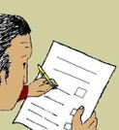
It is always worth making a complaint even, whether you decide to take legal action or not. Good companies that care about their customers look at complaints and use them to make their services better.

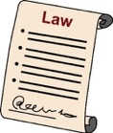
We have put together template letters, which explain to the company how their actions have meant they have broken the law (Equality Act), which you can use. Your complaint could help the company realise that they are doing things that are against the law.

Complaint letters
If you are not sure whether you have a strong case for legal action, it is a good idea to make a complaint first. You may get a better understanding of what the company thinks about what has happened.

They are likely to explain to you why things happened the way they did. It may also help sort out the problem without having to take legal action. It is worth keeping in mind though that normally, once you have started legal action, you won’t be able to raise the same issue as a complaint in the future.

Letters before action
However, you don’t always have to make a complaint before starting legal action. You can send a ‘letter before action’, this is the first step in a possible court case. You can do this instead of making a complaint. This may be taken more seriously, and the company will probably reply by giving you the information you need so that you can decide whether you want to carry on and take legal action.
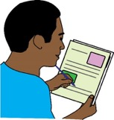
The reason for sending a letter before action is different from a complaint letter. Not only are you letting the company know what went wrong, it also tells them that you will go to court if they don’t make things right.

Some people who do not have much money coming in or who are on benefits can get free legal advice to help them write their letter before action. There is no risk of losing money by sending a letter before action.

- Civil Legal Advice will put you in touch with lawyers who can help you: www.gov.uk/civil-legal-advice
- Download our template complaint letters

Getting evidence
Getting together evidence is important whether you decide to take legal action or to make a complaint. Get evidence on the spot, make a note of the date and time, and if possible take pictures or make a video with your mobile phone.
If you can, make a record of what happened and how it affected you. For example:
- You were not able to use the service
- They wasted your time
- You did not have the same choices as others
- You could not understand what was going on
- You felt upset about how you were treated

It can be important to have written this down or recorded something on your phone the day it happened, so that you don’t forget. It also helps you to explain to the organisation, or to a judge if your case goes to court, what it feels like to be discriminated against in this way.

If you are dealing with a member of staff, ask for their name. If there are people who saw what happened and are happy to support you in making a complaint or taking legal action, make sure to get their contact information.
You have a right to get a copy of all information the organisation has on record linked to your name or any images of you. This can be CCTV footage and records of phone calls you made. To help you get together evidence, you can use this right to get a copy of this information.
In your complaint letter, you can also ask the organisation to send you their policies, procedures and information about any training their staff get.

At the link below is useful information about your rights under the Data Protection law and on how to make a Subject Access Request, including a template letter you can use.
https://ico.org.uk/your-data-matters/your-right-of-access/
Data Protection law: this is a law about how people’s personal information can be used. The main reason for this law is to protect people from abuse through their private information being used in a bad way.
Subject Access Request: this is when a person asks an oganisation for the information that the organisation has about them.

How to make a complaint

Find out who to complain to

It is important to find the right organisation to complain to. You need to send your complaint to the organisation that runs the service that you could not access.

Each organisation should have its own complaints procedure. This will tell you where to send your complaint to and how long it should take before the complaint is dealt with.

Download our template complaint letters

Write a complaint letter

You can use our template letter to write a complaint. Try to do it as soon as possible.

Ask for the evidence you need

You can do it in your complaint letter or in a different letter afterwards. For example, there might be CCTV footage of you trying to enter the building.

Chase for a response

If you do not get a reply within the time given in the organisations complaints procedure, or within the time you gave in your complaint letter, you will need to follow up with the organisation for a reply. You can do this by sending an email or phoning.

There may be different situations you end up in:
- You get a reply and you are happy with it
- The company wants to talk with you about how to deal with what has happened
- You get a reply and you are not happy with it
- You do not get a reply at all

Download our template chasing emails (LINK)

Think about taking further action
If you are not happy with the reply or you do not get a reply, you could think about taking legal action.
If you got a reply, you will probably get some kind of explanation of why things happened the way they did. Read it and think whether the reasons given look like good reasons to you.

Remember the Equality Act means that organisations must think about the possible needs of Disabled people beforehand. It means that they must do what is reasonable to meet those needs.
For this reason, replies that say things such as ‘we did not know you might need information in an alternative format’, will not always be good enough reasons.
Look at our ‘How to deal with most common excuses’ document [LINK] to help you decide what to do next.

Taking legal action
By legal action here we mean starting a discrimination case in the County Court.
You can do this on your own or you can find a lawyer to do this for you.

If you are on means tested benefits, or you do not have much money coming in, you may be able to get government funding to pay for your legal costs, this is called legal aid. Some solicitors may take your case on a “No win no fee” basis, this means that if you do not win then you do not pay anything.
Means tested benefit: these are benefits that people can get if they have below a certain amount of money coming in.

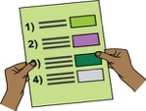
If you think you will need legal advice and someone to take your case to court, get in touch with our Disability Justice Project or see here for the list of organisations to contact.
If you have a lawyer, they will usually write all the documents for you and will guide you through the process.

If you decide to take legal action yourself below are some tips, example documents and links to information and tools that might be helpful:

- Disability Justice Project Guide to Legal Aid
- Doug Paulley’s Disability Attitude Re-adjustment Tool (DART)
- Judiciary.gov.uk – Guides for a person who taking their own case to court
- Justice.gov.uk – Court forms
- Citizen Advice Bureau’s taking court action

Letters
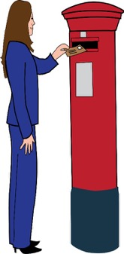
Writing a complaint letter is the first step you will take in starting a legal action. We have made a number of templates you can use to write letters.
See here if you are not sure whether you should write a complaint letter or a letter before action.

If you were not able to enter a building because of not having physical access
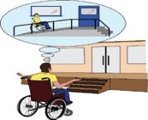
This template can also be used for any other case when a physical barrier stopped you from accessing or using a service like everybody else.

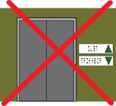
This can be things such as cases when signs were not accessible, there was no tactile paving, or when there are entry phones or lifts that only work when using a person’s voice.
Tactile paving: this is when the pavement has a different feel under your feet for example at places where you cross the road. This is so that visually impaired people can use their feet to feel when there is a road crossing.

Complaint letter
Word template (Easy Read)
Word template
Online letter writer
Letter before action
Word template
Online letter writer

If an accessible toilet was locked

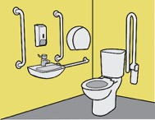
Complaint letter
Word template (Easy Read)
Word template
Online letter writer
Letter before action
Word template
Online letter writer

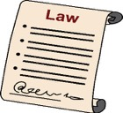
Things to remember:
- Read what the law says.

- It is important to find the right organisation to complain to. You need to send your complaint to the organisation that runs the service that you could not access. Each organisation should have its own complaints procedure, this will tell you where to send your complaint to.
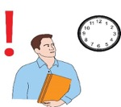
- The time limit for starting a discrimination case in court is 6 months, so send those letters as soon as you can.

The Disability Justice Project
Inclusion London
336 Brixton Road
London SW9 7AA

www.disabilityjustice.org.uk
info@inclusionlondon.org.uk
020 7237 3181

We would like to thank the Equality and Human Rights Commission who funded putting together these guides through their grants programme.

Written by
The Disability Justice Project
Inclusion London
Supported by
The Baring Foundation

