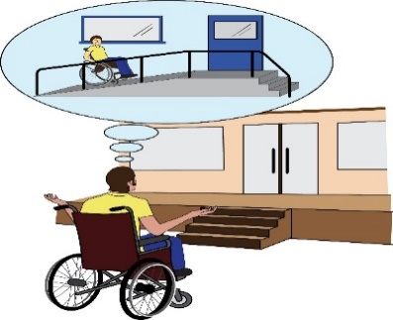
Complaint letter: Accessible toilet is locked

You will need to make changes to this letter, especially where the text is highlighted in yellow

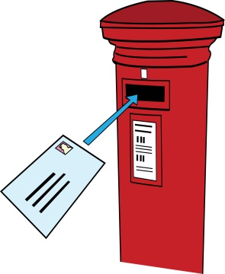
To: Name of the company which provides a service
Address
Also by email

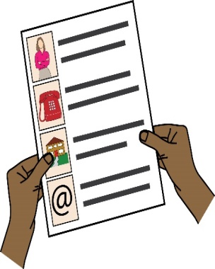
From: your name
Your address:
Your phone:
Email:
Date:

Dear [Company’s name]
Re: Complaint about disability discrimination – the Equality Act 2010
I am writing this letter of complaint because it was very hard for me to use your services. I would like you to make your service more accessible to me and other Disabled people who need information in accessible formats. I think you are breaking the law (The Equality Act 2010). This letter explains what went wrong and what I want you to do to make things right.

I am a Disabled person under the Equality Act 2010
I am a Disabled person within the meaning of Section 6 of the Equality Act 2010.
[Describe your impairment and the impact it has on you. For example: I have a spinal injury and I use electric wheelchair to move around.]

The issue I am complaining about

Describe what happened, with date, time, place. And what went wrong.

For example: On X date at X time I wanted to enter into your shop at X address.] I could not enter as there was a small step at the entrance. I had to shout for someone to come out and asked whether you had a portable ramp so that I could come in. I then was told by (insert the name or position of a person) that there was no ramp. He offered to push me into the building or to serve me outside. I was not prepared to do either of these]
Describe the impact this had on you. For example: as a result I had to go and find another shop that was accessible to me, wasting my time. I feel angry and as if I’m a second class citizen. I was made to feel like I was guilty for not being co-operative and for wasting other customers’ time, when the only thing I wanted was to shop like everybody else does. This experience made me anxious. I feel my choices are restricted to large supermarkets, which are quite far away.

How you broke the law (Equality Act 2010)
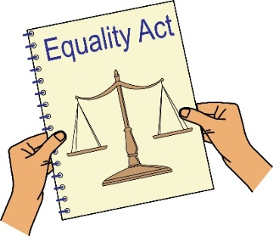
You are a service provider under Section 29 of the Equality Act 2010. Section 15 of the Equality Act says you must not discriminate against Disabled people because of something that comes as a result of their disability.
Section 20 of the Equality Act 2010 says you must take reasonable steps to make sure Disabled people like me can access your services like everybody else.

Those steps should be:
- Changing policies or the way you run your service
- Removing physical barriers
- Giving extra support or help (auxiliary aid or service).
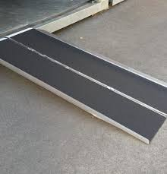
The step at the door is a physical barrier which prevents me from using your service: you should have taken reasonable steps to remove it. If it is not possible or reasonable for you to remove the step, you should have considered providing auxiliary aid – a portable ramp to enable me to use your service. By failing to do this you have discriminated against me.
I believe the help you offered me was not good enough. It did not respect my dignity or independence..

Obtaining information
Please send me the following information about the case that I am complaining about.
CCTV footage of me taken on the day [insert date and time and describe how you look].
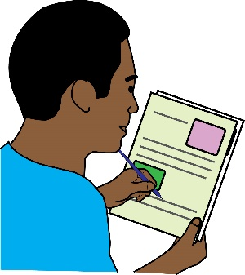
What I would like to bring about through this complaint
- You agreeing that what you have done is wrong and saying sorry to me in writing.
- You either removing the step or buying a portable ramp.
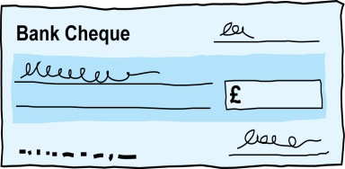
- Compensation for the discrimination and hurting of my feelings that I experienced.

Duties: this is something that someone or an organisation must do by law.
Compensation: this is something given to someone because of loss or suffering. It is usually money.

Next Actions
I very much hope we can sort this out. I look forward to hearing from you within the next 21 days. If you believe you have not broken the law (Equality Act 2010), please give your reasons.
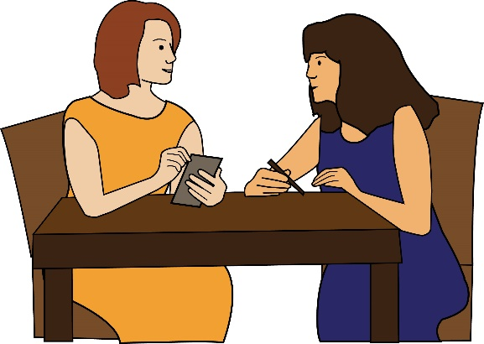
I am happy to talk with you about how we can deal with this issue. However, if I do not hear from you, or if you believe that you have not broken the law (Equality Act 2010), then I will think about taking legal action against you.

Yours sincerely
(Your name)

