Complaint letter: Accessible toilet is locked

You will need to make changes to this letter, especially where the text is highlighted in yellow

To: Name of the company which provides a service
Address
Also by email

From: your name
Your address:
Your phone:
Email:
Date:

Dear [Company’s name]
Re: Complaint about disability discrimination – the Equality Act 2010
I am writing this letter of complaint because it was very hard for me to use your services. I would like you to make your service more accessible to me and other Disabled people who need information in accessible formats. I think you are breaking the law (The Equality Act 2010). This letter explains what went wrong and what I want you to do to make things right.

I am a Disabled person under the Equality Act 2010
I am a Disabled person within the meaning of Section 6 of the Equality Act 2010.
[Describe your impairment and the impact it has on you. For example: I have a spinal injury and I use electric wheelchair to move around.]

The issue I am complaining about
Describe what happened, with date, time, and place. For example: on X date at approximately X time I visited your restaurant at X address]
[Describe what exactly went wrong. For example: I needed to use the toilet, but the accessible toilet was locked. I asked a member of staff to open it, but was told that it was not possible as it was not in use.]
[Describe the impact this had on you,
For example: as a result I had to rush quickly to frantically search for an accessible toilet, it was physically painful, extremely inconvenient, stressful and most importantly humiliating.]

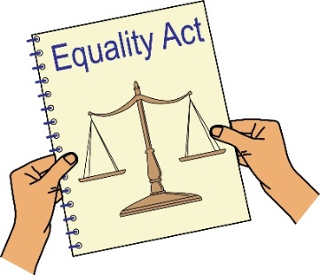
How you broke the law (Equality Act 2010)
You are a service provider under Section 29 of the Equality Act 2010. Section 15 of the Equality Act says you must not discriminate against Disabled people because of something that comes as a result of their disability.
Section 20 of the Equality Act 2010 says you must take reasonable steps to make sure Disabled people like me can access your services like everybody else.

Those steps should be:
- Changing policies or the way you run your service
- Removing physical barriers
- Giving extra support or help (auxiliary aid or service).
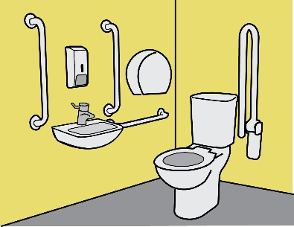
Although there was an accessible toilet, which would have enabled me to use your service like everybody else, it did not work. I do not see how it can be ok for you to use the accessible toilet for any other purpose or to lock it. You would not do so with other toilet facilities.
Section 15 of the Equality Act makes it unlawful for you to treat Disabled people badly because of something arising as a consequence of Disability. As a consequence of Disability, I can only use an accessible toilet. Your practice of locking your accessible toilet and using it for other purposes has made me less equal. I do not see how this there can be a good reason for this.
By failing to ensure the accessible toilet is working properly and is available for your Disabled customers to use, you have discriminated against me.

Obtaining information
Please send me the following information about the case that I am complaining about.
CCTV footage of me taken on the day [insert date and time and describe how you look].
What I would like to bring about through this complaint
- You agreeing that what you have done is wrong and saying sorry to me in writing.
- A change in the way you run your service making sure Accessible toilet if always open for Disabled people to use.
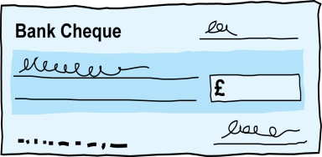
- Compensation for the discrimination and hurting of my feelings that I experienced.

Duties: this is something that someone or an organisation must do by law.
Compensation: this is something given to someone because of loss or suffering. It is usually money.

Next Actions
I very much hope we can sort this out. I look forward to hearing from you within the next 21 days. If you believe you have not broken the law (Equality Act 2010), please give your reasons.
I am happy to talk with you about how we can deal with this issue. However, if I do not hear from you, or if you believe that you have not broken the law (Equality Act 2010), then I will think about taking legal action against you.

Yours sincerely
(Your name)

